CP Rail Radio System Use cases
Use Case 1 – General console calls
Use Case 2 – Emergency calls
Use Case 3 – Local Repeat
Use Case 4 – Extended Repeat
User Case 5 – Buddy Timer
Use Case 6 – RTI Calls
Other Radio use cases include Time Signal access from field to hear accurate time over the radio. This is detailed in CP Time Tables.

Use Case 1 – General console calls. To and from radio consoles, this supports general dispatch or specialty consoles (Diesel Doctor).
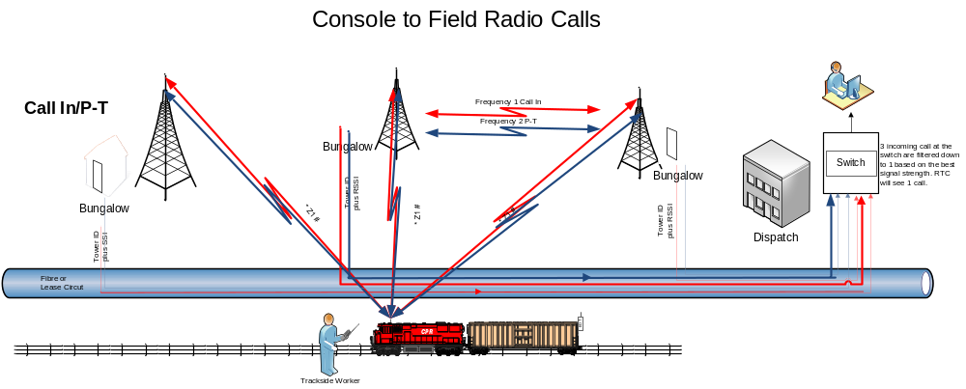
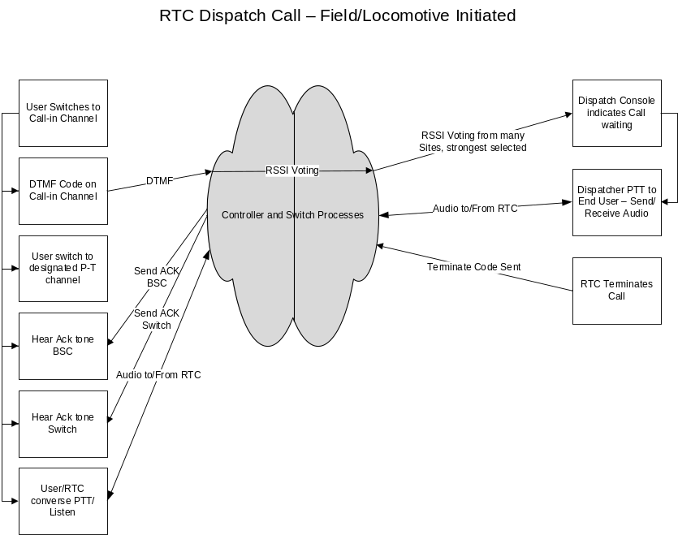
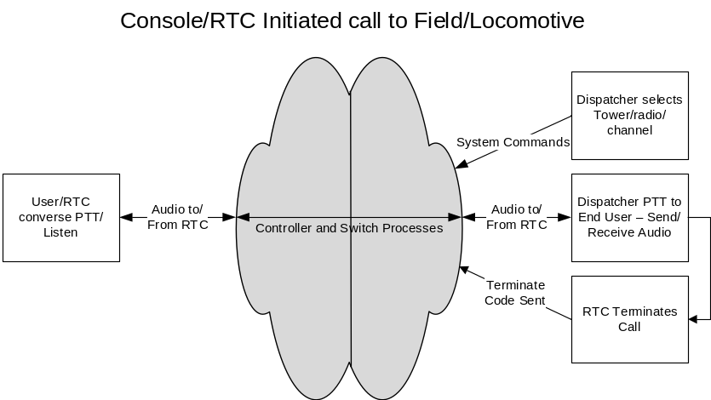
Use Case 2 – Emergency calls. Emergency calls get priority and allow immediate communications to console operator.
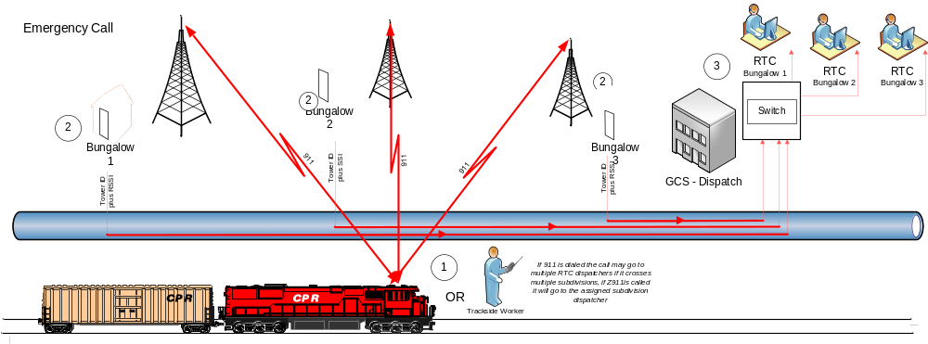
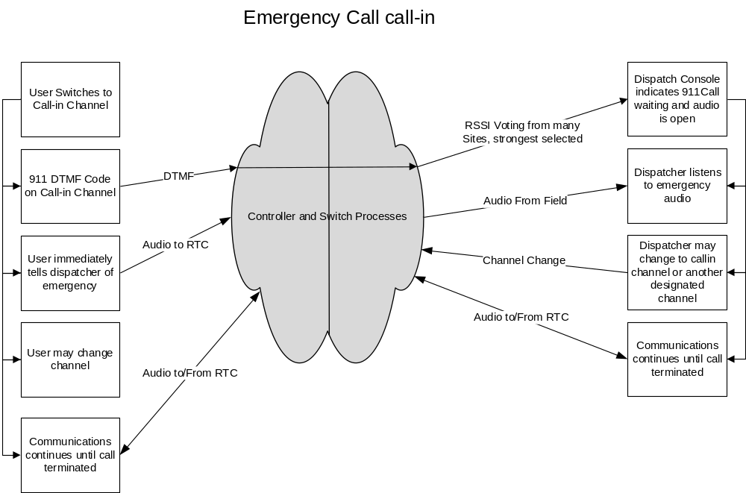

Use Case 3 – Local Repeat. Allows field users to speak to each other over a local repeater channel. Console operator may monitor or break into radio to speak to field personnel.

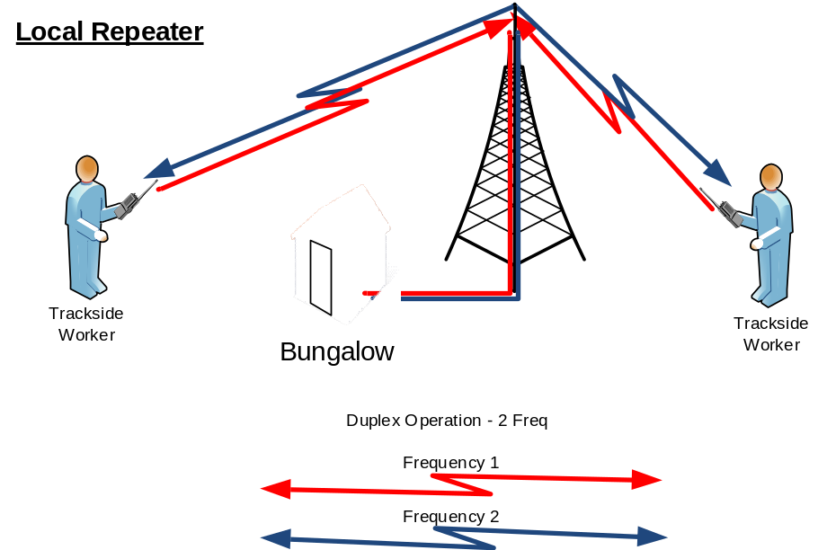

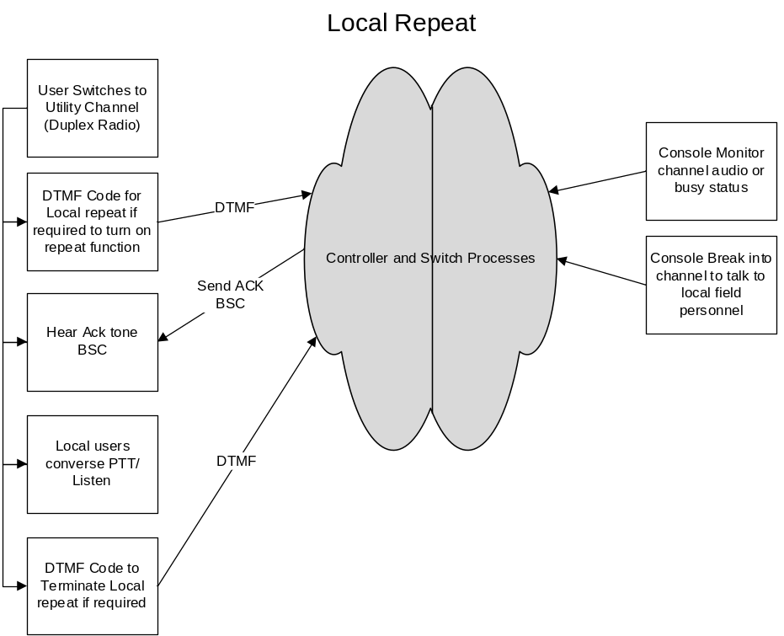

Use Case 4 – Extended Repeat. Allows MOW crews in multiple sites to communicate to each other. This function may also be used on non-repeat channels as a line-up function for a console operator to transmit on multiple towers simultaneously.
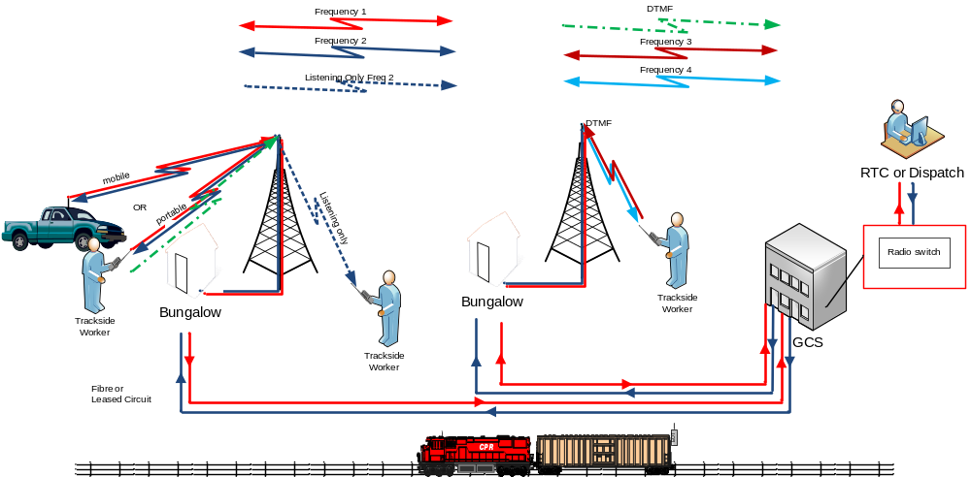

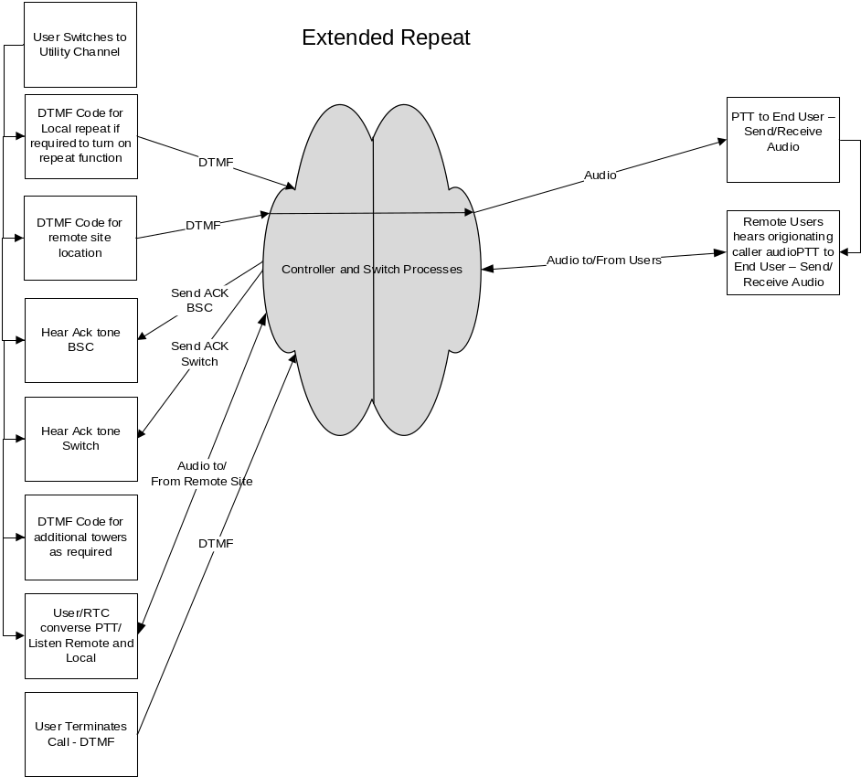
User Case 5 – Buddy Timer. Allows a dispatcher to determine if a alone worker is OK or needs help.
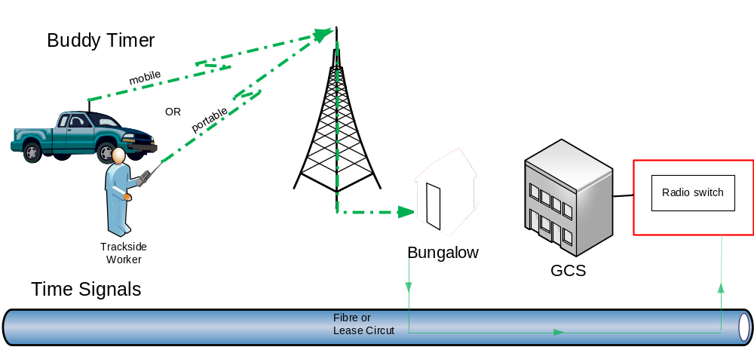

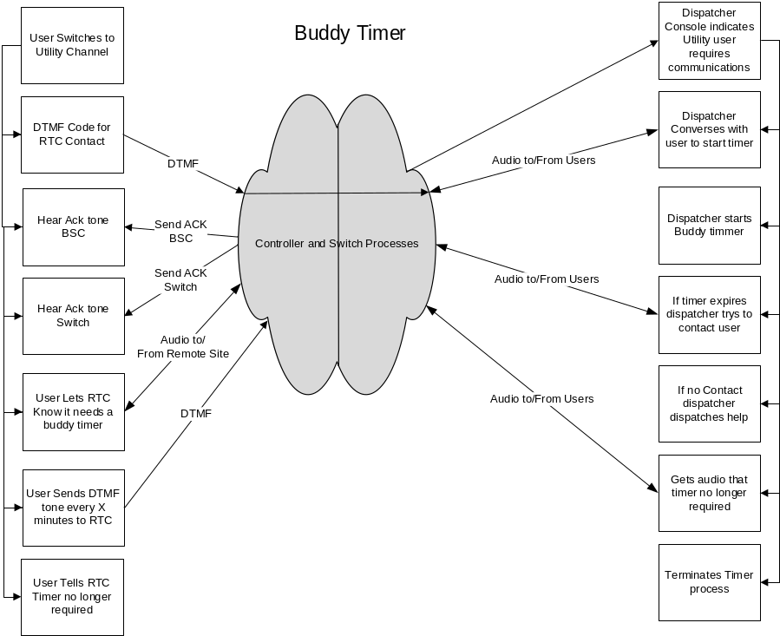

Use Case 6 – RTI Calls. Allows field user to reach console operator or vice versa if primary communications link is broken through a normal POTS line. Is also used by a non console operator to access specific tower sites for radio communications.
